Competitive Bidding for the provision of subsidies for
Universal Service in Rural New Mexico
Developed by Martha García-Murillo

Governor Gary E. Johnson of New Mexico issued a call for competitive bidding to offer Doña Ana County broadband services. The County comprises 3,804 square miles in south-central New Mexico, bordering on El Paso County, Texas, to the East and Southeast and the state of Chihuahua, Mexico, directly to the south, as well as Luna County to the west, Sierra County to the north and Otero County to the east. There are many physically diverse areas within Doña Ana, including mountain ranges, valleys and deserts.
By 1990, the county was urbanized with a population of 135,510 and boasted an economy based on service and retail. Rapid population growth has occurred in and around the city of Las Cruces, as well as in the southern part of the county. The part of the county north of Hill remains primarily rural in nature. The population has risen dramatically since 1990s and is expected to continue to grow at a rapid pace (4 - 6 percent) during the next 20 years. This translates to a 2020 population of more than 400,000 people. The primary areas of growth will be in the Las Cruces metropolitan area and in the southern sector of Doña Ana County.

The average distance between houses is 150 ft which in an urban area ranges between 3 to 20 ft while in a rural area it is approximately 200ft. This means that you could be serving between 75 and 105 houses in an urban setting while in a rural community you would be serving approximately 25 houses per square mile. 73% of the population live in an urban setting while 26% live in rural areas.

CO | CO
Urban average distance 3-20 ft Rural average distance 200 ft

The average cost to set up local loop is about $300,000 per square mile which will need to be recovered in 15 years. Since you will be participating in a reverse bidding auction you need to determine the minimum amount monthly cost per household for both rural and urban and then decide on the price you will charge these two types of household which will have to be the same under the tariff equivalency requirements. How much will you need from the government if any?
My company’s minimum bid is: We will need a subsidy of $163,333.33 in order to turn a profit of 100k.

The average cost per home, at break even, is $44.44. At 100k profit, that number is $59.26. A difference of $14.81. The average cost per house is per house is $14.81 * months in a 15year period = $2666.67. According to the information, there are between 75:105 urban houses per square mile, and 25 rural houses per square mile. At a 73%/26% split, this equals out to an average of 61.25 homes per square mile. **Spreadsheet attached, but main calculations below.

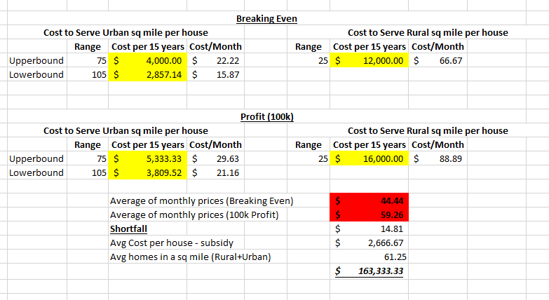

SOME TIPS TO PREPARE YOUR BID:
- Like in real live some information is irrelevant and you will have to determine what is useful.
- Some information you need is not there so you will need to assume somethings to prepare your bid. When you prepare your answer make sure you let me know the assumptions you made.
- Most students get fooled by the average distance per houses info…
- Don’t make the problem more complex than it already is. In other words don’t try to calculate annual population growths or depreciation of the capital investment. Simply assume that the project will end in 2020 and you will want to serve the entire population.
- Remember that you are a company so you will need to charge a price and if you don’t cover your costs then you can ask the government for the subsidy.
- One important piece of information, in the US as in many other countries you cannot price rural households a higher price than the urban households. So even though it is more expensive to provide them service, you need to charge the same price. This is known as rate parity.
- Use a spreadsheet it will make your calculations easier
- Remember the government will give you the project if you propose the lowest bid per household per month.

